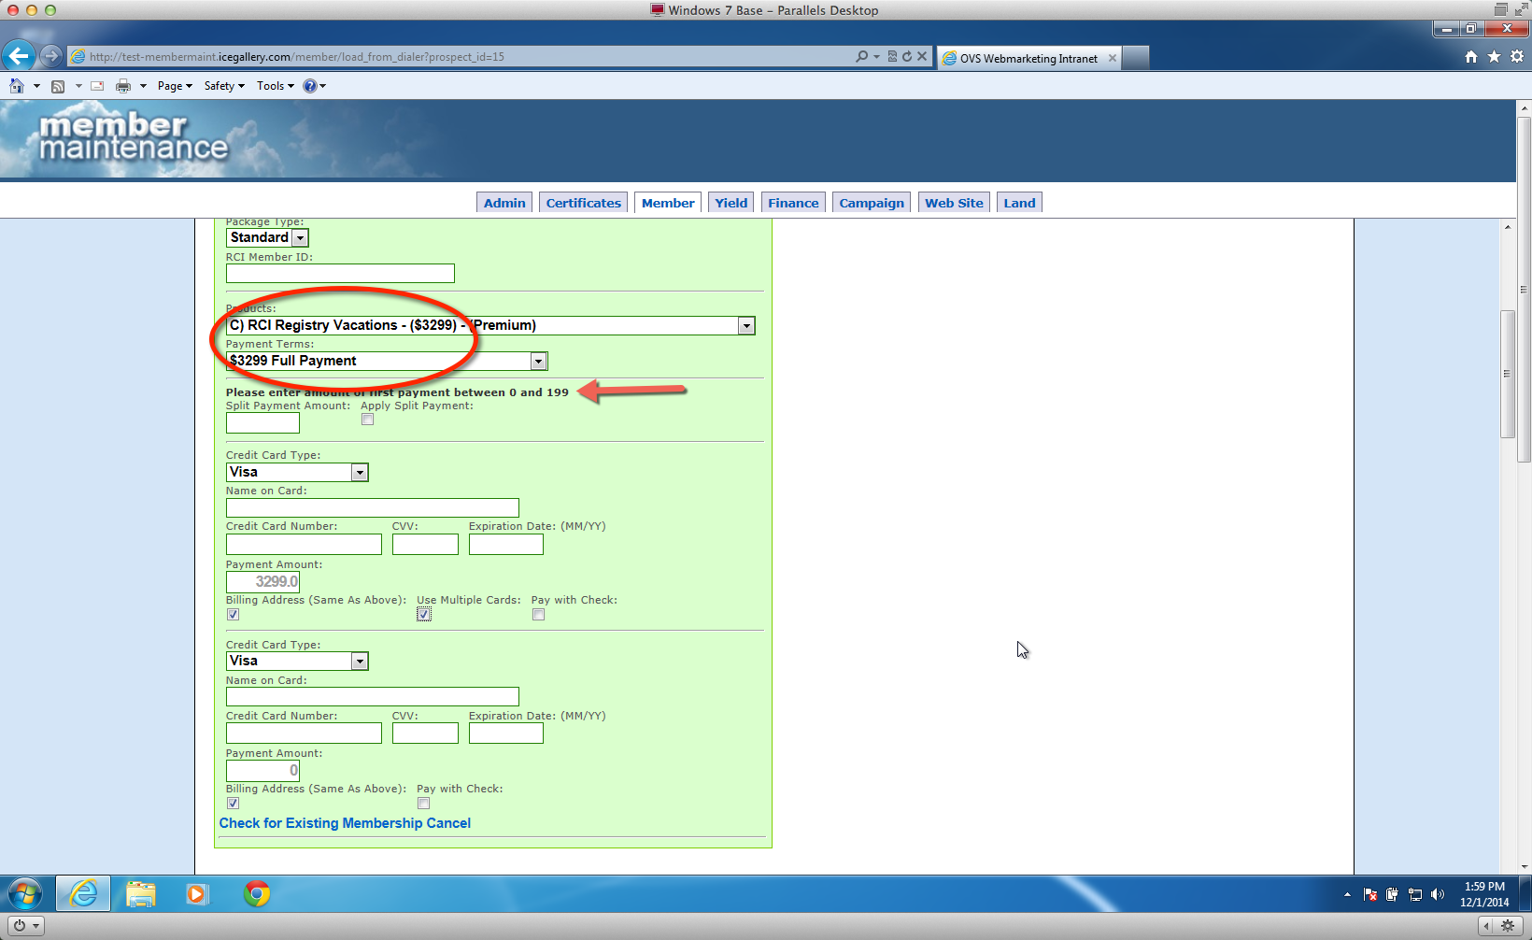

Chose a different payment option from the drop down. Then went back to the $3299 Premium option and then the text adjusted to the correct full payment amount.

